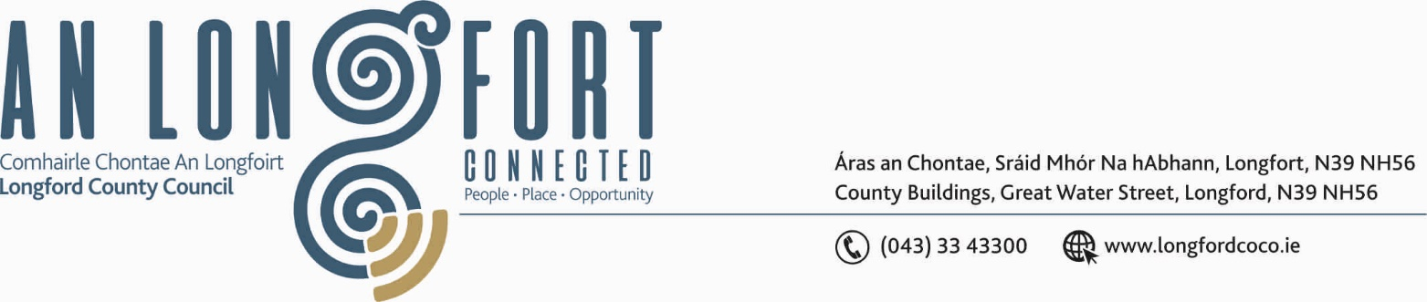

Please note meeting venue – Council Chamber, Aras an Chontae.

GRANARD MUNICIPAL DISTRICT

10th June 2019.

To: Each Member of Granard Municipal District.

Dear Member,

You are requested to attend the First Annual Meeting of Granard Municipal District to be held in the Council Chamber, Aras on Chontae, Great Water Street, Longford on Monday, 17th June 2019 at 5.00 p.m. to transact business, as set out on the Agenda hereunder.

Yours sincerely,
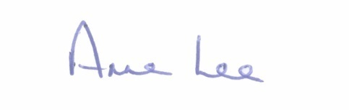

_______________
Anne Lee,
Meetings Administrator.

C L A R

1. Election of Cathaoirleach.

2. Election of Leas Cathaoirleach .

/2……

3. Nominations to Committees – referred from Longford County Council
2019 Annual Meeting -

 | Committee | Frequency of Meeting | Venue of Meeting
(a) | Appointment to Longford Enterprise Development Company Ltd -  One Member from Granard M.D.  One Member from Ballymahon M.D.  Two members from Longford M.D. | Quarterly | Aras an Chontae.
(b) | Appointment of Cathaoirleach and three members from each Municipal District to the Regeneration Committee. | Quarterly | Aras an Chontae.
(c) | Appointment of one Member from each Municipal District to the Creative Ireland Culture Team. | Five meetings  per year. | Aras an Chontae.
(d) | Appointment of one member from each Municipal District to the County Longford Heritage Forum. | Quarterly | Aras an Chontae.
(e) | Appointment of one member from each Municipal District to County Longford Tourism Committee. | Six meetings  per year. | Aras an Chontae.

4. Fix date and time of Granard Municipal District meetings.



